Belgrave St. Bartholomew’s
Academy

Co-principals:

Mrs Rachel McNamara, Mrs Luci Baker

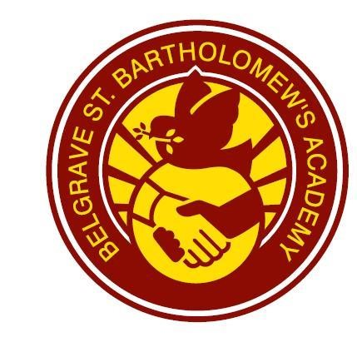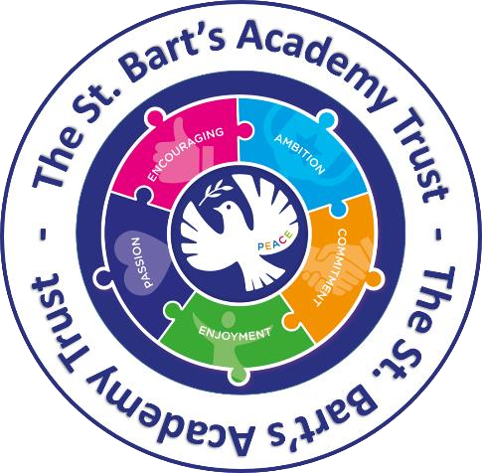

Feedback and Assessment Policy

If you would like this translated in Urdu, please contact the school office.

Intent
Feedback at Belgrave is intended to systematically check the understanding of pupils, identify misconceptions and provide clear next steps for progress.

What is Feedback at Belgrave?
At Belgrave we acknowledge that feedback comes in a variety of forms. The main purpose of feedback is to support children in making progress and celebrating children's learning. Feedback must be clear and specific. The best quality feedback allows children to understand how to improve and respond to make progress. The four key areas that ensure effective feedback are identified below:

Quality Feedback is…
Timely- when best and most effective.
Robust- ensures progress and development.
Regular- feedback happens in all lessons at appropriate points.
Positive- there is an expectation that feedback will have a direct positive impact on pupils’ outcomes.

Timely
At Belgrave we have identified that instant verbal feedback is the most powerful means of feedback. It supports children in understanding, retention of information and helps reduce the development of misconceptions. This feedback takes place live in lesson time and there is no expectation for staff to record verbal feedback.

Robust
Staff track and identify how children have achieved against objectives, using a variety of methods including: emoji feedback on Showbie, scores through Socrative assessment, feedback through BSquared assessment frameworks and the use of Dojo in EYFS. This may result in an intervention or an extension or application of skills and knowledge during a daily reflection time where children review their feedback from the previous lesson.

Regular
Feedback happens in every lesson and during continuous provision. Teachers consistently support and challenge children through effective feedback and questioning. Support Staff scaffold learning and to give pupils instant verbal feedback in order to motivate, address misconceptions and provide next steps.

Positive
The positive nature of feedback promotes growth mindset. The use of emojis, for example, gives children instant feedback and celebrates learning in their lesson. Children have a weekly Celebration worship where successes are celebrated and shared. Additionally, Showbie portfolios and ClassDojo are used to showcase work and achievements with parents.

Implementation

Where will you see feedback?
- Verbal exchanges: Teacher, TA and peer discussion in lesson time.
- Emojis (see appendix 1)
- Ticks may be used to identify a correct answer and dots to show children incorrect answers.
- Next steps and challenges provided during reflection/retrieval time at the start of lessons.
- Peer/self assessment.
- BSquared
- ClassDojo
- Marking codes (see appendices 2,3,4)
It is important that children can explain (using appropriate communication strategies where needed) how they receive feedback and how it supports them in making progress.

Assessment at Belgrave
Assessment at Belgrave is used to identify gaps in learning and inform teachers/children of their next steps. Gaps in learning will then be addressed through the appropriate means to ensure the best chance of progress for each individual child. Work will be uploaded on to Showbie, ClassDojo or BSquared for feedback and assessment.

During each lesson staff will make formative judgements on pupils’ progress and intervene through live feedback and support when required.
In Key Stages 1&2, class teachers assess children’s progress towards an objective using emoji feedback. These emojis allow children to celebrate their progress and also allows staff to identify what the next steps are for individuals, groups and classes. (See Appendix 5 for which subjects emoji marking is used in.) In Early Years, children are assessed against the Early Years Framework and this is evidenced on ClassDojo. For children with SEN, including in The Ark, assessment is carried out through the BSquared system (see below). Subject leaders have developed progression maps and minimum expectations for each year group in order to support class teachers making judgements.

From daily assessment staff may:
- Provide a fix-it opportunity (Reflection Time),
- Provide a small group intervention (Reflection Time),
- Complete a whole class re-teach.

Summative assessments are used to support teacher judgements and encourage discussion and reflection around progress of individuals. The assessment also allows staff to identify gaps in learning and adapt future planning to cover these.
See appendix 5 for summative assessments in relevant subjects and when these occur.

Children’s gaps in learning are met through:
- Retrieval practice,
- Spaced practice,
- Small group intervention (Reflection Time),
- Whole class re-teach.

Assessment for children with Special Educational Needs
At our school, we use BSquared Connecting Steps to assess and track the progress of pupils with Special Educational Needs (SEN), particularly those working below age-related expectations. This tool allows staff to record small, meaningful steps of progress across academic and developmental areas, providing a clear picture of each learner’s journey. It supports personalised planning, informs teaching strategies, and enables effective communication with parents and professionals about individual achievements and next steps.

Impact
Children make continuous improvement across all curriculum areas and within their social/emotional development. Staff can coherently discuss their class’ progress, individual needs, identify gaps and act on these appropriately. Children can confidently talk about (using relevant communication strategies where necessary) the impact of feedback and show examples of this.

Date: September 2026 Review Date: September 2027

Appendix 1:
The emojis used to assess, promote and celebrate learning on Showbie.

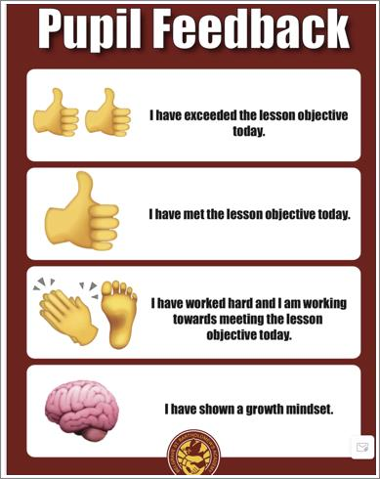

Appendix 2:
Codes used to guide children in next steps and also to support teachers in making judgements for assessment.

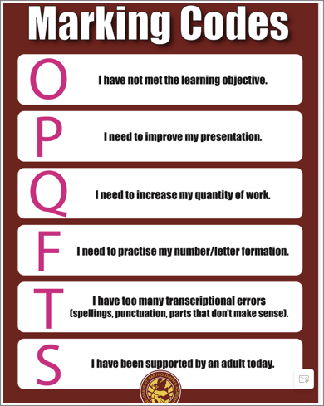

Appendix 3:
Symbols used to support and promote the effective use of expectations in writing across the curriculum.
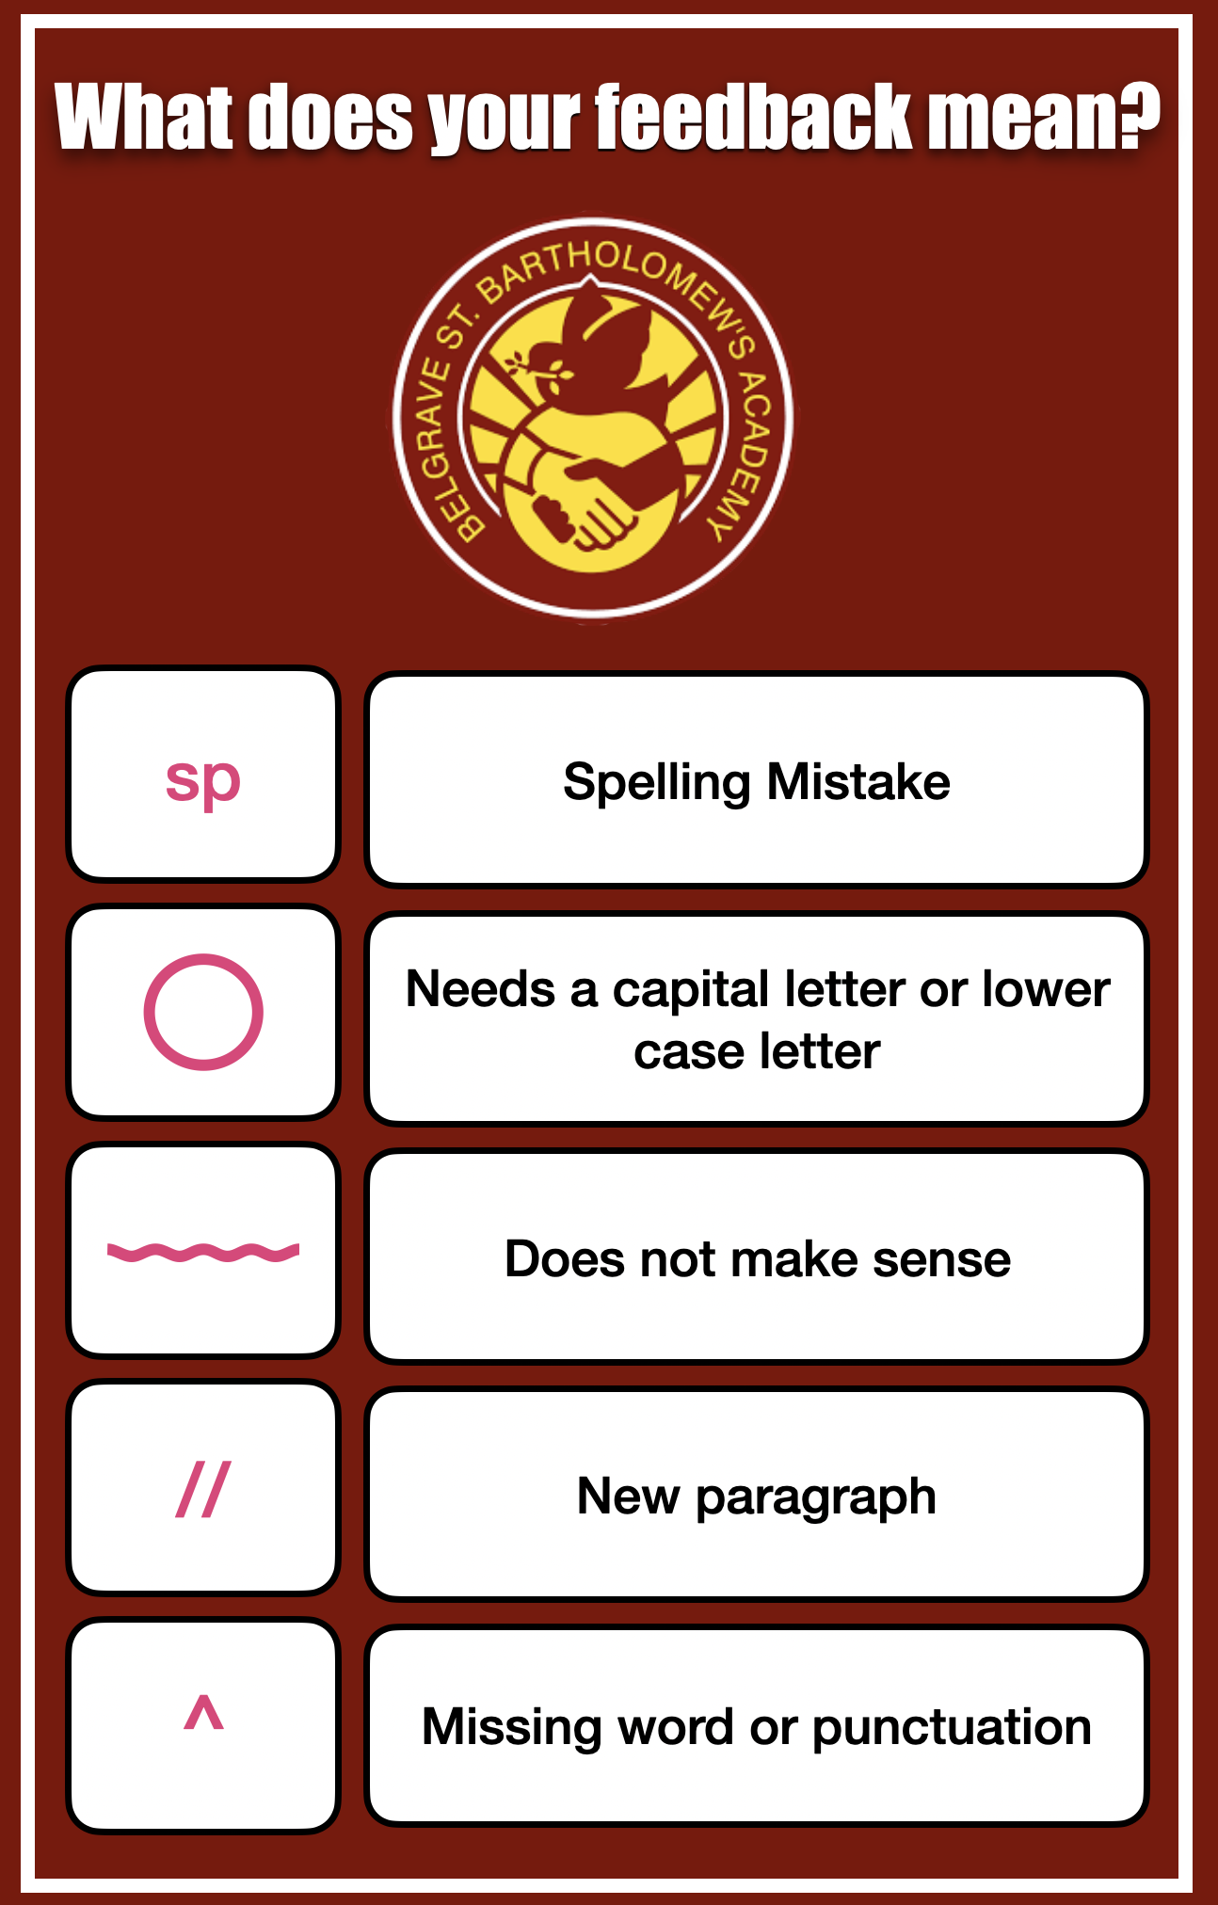

Appendix 4:
Symbols poster examples used in classrooms.

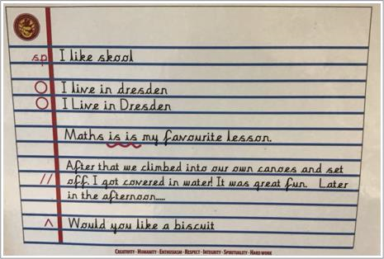

Subject | Showbie Feedback | Summative Assessment
English | Lesson feedback using emojis and marking codes  Reflection Time | Writing: Extended Success Criteria  Reading: Reading Domain Overview (Teams) - termly
Maths | Lesson feedback using emojis and marking codes  Reflection Time | Post Unit Assessment (Teacher Created ie Testbase / White Rose)
Science | Lesson feedback using emojis and marking codes  Reflection Time | During Unit: TAPS Assessment  End of Unit: Socrative
History | Lesson feedback using emojis and marking codes  Reflection Time | End of Unit: Socrative
Geography | Lesson feedback using emojis and marking codes  Reflection Time | End of Unit: Socrative
Design and Technology | Lesson feedback using emojis and marking codes  Reflection Time | End of Unit assessment of final product.
Art and Design | Lesson feedback using emojis and marking codes  Reflection Time | End of Unit assessment of final piece.
RE | Lesson feedback using emojis and marking codes  Reflection Time | End of Unit: Socrative
PSHE | Self-reflection/voice note from children | Ongoing assessment throughout.
Computing | No Showbie Feedback | Ongoing assessment throughout (linked to domain).
PE | No Showbie feedback | End of half term assessment against objectives.
MFL | No Showbie feedback | End of Unit: Primary Languages scheme assessment.
Music | No Showbie feedback | Ongoing assessment throughout.
Appendix 5:

