Belgrave St. Bartholomew’s
Academy

Co-principals:

Mrs Rachel McNamara, Mrs LuciBaker

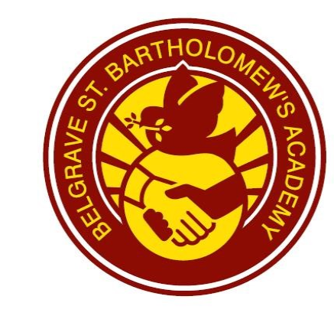
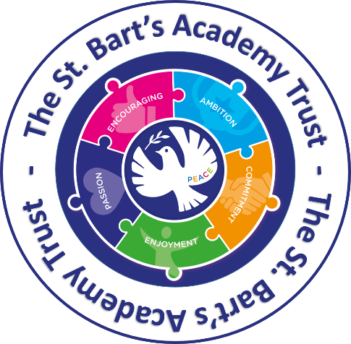

Nut Aware
Policy

If you would like this translated in Urdu, please contact the school office.

“An inclusive family under God.”
Loving each other as we love ourselves Matthew 22:39.
Nut Aware policy

Belgrave St. Bartholomew’s Academy are food allergy aware. This does not mean that we are ‘nut free’. We aim and strive to minimise the risk to children with allergies whilst appreciating that we cannot be completely confident that all food items brought in are nut free or that another child has not consumed nuts before coming into school.

There are a considerable number of students at our school who have severe food allergies. The most common of these allergens are peanuts, tree nuts, eggs, fish, and chickpeas. The most serious risk in our school is nut allergies which can cause life threatening anaphylactic reactions to some of our students.

Aims of this policy
- To provide a safe learning environment for all members of the school community
- To raise the awareness of all members of the community regarding severe allergies

Management
The Nut Aware policy will be managed by:
- Parents and caregivers being requested NOT to send food to school that contains nuts (especially peanuts). This includes all types of nuts, peanut butter, Nutella and food containing nuts.
- Our school kitchen and food are already nut free and we do not supply any ingredients in food technology that have nuts or nut derivatives.
- Staff supervising eating at lunchtime.
- Students being encouraged NOT to share food.
- Students being encouraged to wash hands before and after eating.
- Staff training in understanding and dealing with Anaphylaxis (severe allergic reactions)

Promotion
The policy will be promoted by:
- A copy of this policy being made available for all parents.
- Staff being informed and provided with training opportunities.
- Publication of this policy on the school website
- Pupils being informed via teachers and support staff- alternative options recommended
  - Helping students to understand that foods they can enjoy eating can also be dangerous to others
  - Encouraging students to support their classmates with allergies by eating and handling food responsibly

Risk Assessment regarding Nut Allergy
- Staff will be alert to any obvious signs of nuts being brought in, but they will not inspect all food brought into school.
- If staff do notice a student that has brought in food that contains nuts or nut products these items will be removed and if required, an alternative will be provided from the school kitchen.

