Belgrave St. Bartholomew’s
Academy

Co-principals:

Mrs Rachel McNamara, Mrs LuciBaker
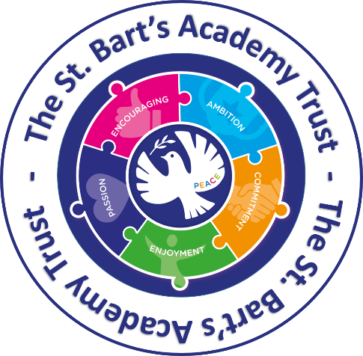


Parent Partnership Policy
2026.27

If you would like this translated in Urdu, please contact the school office.

PARENT PARTNERSHIP POLICY

“An inclusive family under God.”

Loving each other as we love ourselves. Matthew 22:39.

Belgrave St. Bartholomew’s Academy is an inclusive, happy and thriving ‘family’ community. Education is a collaborative journey between the school, parents/carers/family members, pupils, governors, the local community and national agencies. We continue to strengthen our links and work closely with parents, carers, friends and businesses within the local community to provide enriching opportunities for our pupils.

Aims
The aims of our parent partnership policy are:
- To communicate regularly and effectively with parents/carers through a range of media
- To involve parents/carers in a range of school activities
- To work with close cooperation between school and home
- To provide an inclusive environment, in which everyone feels welcome and valued

We work tirelessly to ensure that Belgrave St. Bartholomew’s Academy is a friendly and welcoming environment for all parents/carers and visitors. There are many ways in which our parents/carers are able to communicate with the staff at Belgrave.

Methods of communication with our families:
- Regular newsletters (at least once per half term) – uploaded to Class Dojo and the school website
- Letters and Class Dojo posts informing parents/carers of specific events and activities
- Website for all policies, procedures, ‘latest news’ and curriculum information
- Class Dojo messages and occasional text messages to remind parents/carers about forthcoming events, trips and important messages
- Class Dojo communication app for the classroom, connecting teachers, parents and pupils via direct 1-1 messaging and also a classroom stories (news) section
- Telephone calls
- Face-to-face communication with class teachers, support staff, our extended home-school links worker (Mrs L Jones), and members of SLT (whichever is appropriate)
- ‘Boom Reader’ for communication about pupil’s reading at home and in school
- Parent questionnaires
- Meet The Teacher events
- Parents evenings
- Annual reports

Opportunities for parents/carers to get involved with their children’s school experiences:
- Supporting event days and activities such as;
  - Charity events
  - Easter Bonnet Parade
  - Eid Fair

  - Book Fair
  - Summer Fair
  - Christmas Fair
  - Christmas stall (supporting our Green Giants Allotment)
  - Allotment stalls (i.e. for Mother’s Day)
- Attending curriculum events e.g. Come Read with Us
- School performances, e.g. Nativities, Y6 Show
- Award Ceremonies including Superstar worships
- A range of adult learning opportunities, e.g. parent/carer workshops and joint activities with parents/carers and their children
- Parent/family volunteers and work placements, when available
- ‘Drop-In’ sessions for parents who would like further information on courses, applications, housing etc.

Support for Parents/Carers who have children with SEN:
We are committed to building strong, respectful partnerships with parents and carers of children in the SEN unit, recognising them as key partners in their child’s learning and development. Regular, open communication ensures that decisions are made collaboratively, with the child’s individual needs, strengths, and best interests at the heart of all planning. Parents are actively involved through review meetings, shared target setting, and ongoing dialogue about progress, support strategies, and next steps. Through shared understanding and trust, we aim to create a supportive environment where every child can thrive.

Before and after school provision:
- ABC Before and After School Club
- A range of after school clubs until 4.00pm
- Sporting/team activities, such as football and cross country
- After-school booster classes in Maths and English (by invitation)

Transition arrangements
We feed into a range of Secondary Schools in the area. We work closely with these schools to ensure that pupils attend the relevant transition days and parents/carers are made aware of the open evenings provided by the Secondary schools. To ensure that transition runs as smoothly as possible and pupils and parents/carers are aware of the options available to them, a range of activities for Years 4 to 6 are organised and led by our local Secondary Schools.

Home-school Partnership
Parents/carers are highly supportive of the school and communicate with us regularly through a variety of forms. We pride ourselves on being a reflective school with an open door policy and welcome feedback from parents/carers through the use of Class Dojo, social media, questionnaires, written (emails and letters) and also verbal 1-1 feedback and discussions, either informally before or after school or via a pre-planned appointment e.g. Parents’ Evening.
Any new pupils/families starting the school during the school year will be met by the Academy Principal, or a member of the Senior Leadership Team. Mrs Jones (Extended Home School Links Worker) works closely with a number of outside agencies and is also on hand to meet with parents/carers to discuss any matters relating to school and/or their child or children. Bi-lingial staff are also on hand to support parents, and can help with a range matters, including applications and support information from outside agencies. We pride ourselves on being a highly supportive school. We always aim to help where we can, or at least direct parents/carers to the right place.
A home school agreement is also available on our school website.

Policy Date: September 26 Review date: September 27

