Belgrave St. Bartholomew’s Academy

Co-principals:

Mrs Rachel McNamara, Mrs LuciBaker

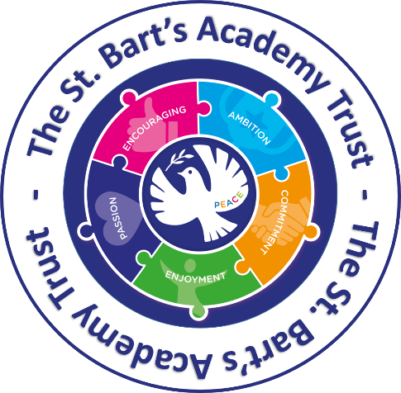


Relationships, Commuication and Behaviour Policy
2026.27

If you would like this translated in Urdu, please contact the school office

Relationships, Communication and Behaviour Policy

Belgrave St. Bartholomew’s Academy is a place where every person has the right to be themselves, to be included and to learn in a safe and happy environment. Everyone at our school is equal and treats each another with mutual respect and kindness. This is consistently upheld through our C.C.R. Values: Courage, Compassion and Respect.

Introduction:
Belgrave St. Bartholomew’s Academy is committed to creating an environment where positive relationships are at the heart of productive learning. Staff and pupils seek to ensure that our school is a safe and caring learning environment where all pupils are supported to develop and maintain healthy relationships, and to learn to take personal responsibility for their behaviours.
Belgrave St. Bartholomew’s Academy is an inclusive family under God which nurtures a caring community whose values stem from our Christian ethos and we encourage mutual respect for all. Every child needs to feel that they belong, are respected and valued. We recognise that our school has children from a diverse range of cultures, backgrounds and family types, who have a variety of learning styles and behaviours.
In all relationships in school, we model the school values of courage, compassion and respect, and we believe this creates an environment where pupils can flourish.

Legislation and statutory requirements:
This policy is based on advice from the Department for Education (DfE) on:
- Behaviour in schools
- The Equality Act 2010
- Supporting pupils with medical conditions at school
- Special Educational Needs and Disability (SEND) code of practice.
- Keeping Children Safe in Education
- RSE/PSHE Guidance

Relationship-Based Approach:
Our relationship-based approach incorporates three key ideas from inclusion philosophy:

Unmet Need: Behaviour communicates an unmet need. Therefore, to change behaviour, we must respond to the unmet need.
Individual Influences: Children’s behaviour cannot be fully understood in isolation without considering their individual influences.
Relationship-based, restorative approaches offer an evidence-based alternative to zero- tolerance behaviour management systems.

In our relationship-based approach, we aim to:
- Provide an inclusive, safe and positive environment in which pupils can learn;
- Ensure all pupils develop personal confidence and have a voice that will be listened to;
- Ensure pupils develop personal resilience and understanding that difficulties can be overcome with the right solutions;
- Support pupils to develop skills in emotional self-regulation;
- Understand that often behaviour can be a form of communication which indicates an underlying need or difficulty. In responding to the behaviour of pupils we aim to identify these needs so that appropriate provision can be planned and pupils can be equipped with the skills necessary to develop behaviour for learning;
- Link behaviour and emotional states to readiness for learning and ensure that pupils understand this link and can self-regulate;
- Engage pupils in a consistent dialogue from all members of staff with regards to behaviour;
- Provide individualised approaches to behaviour if and when required by pupils with neurodiverse or social and emotional needs;
- Create and maintain a positive and safe school climate where effective learning can take place and all pupils can grow socially, emotionally and academically, with mutual respect between all members of the school community, for belongings and the school environment

Our School Community will:
- Apply the guidance contained in this policy.
- Engage pupils in discussions about behaviour using emotional self-regulation approaches where appropriate.
- Report significant incidents to the senior leadership team and record them on Arbor and/or CPOMS.
- Take responsibility for responding to the behaviour of pupils and take appropriate action.
- Promote positive behaviour through being good role models for others.
- Tackle any form of bullying in line with our anti-bullying and child protection policies.
- Actively promote an inclusive ethos throughout school.
- Seek support, if unsure, from key members of staff with expertise such as DSL/DDSLs, SENCo, school counsellor or our designated Mental Health Educational Practitioner.
- Adopt child-centred approaches by listening to pupils and considering their perspectives. These will include awareness of Attachment and Trauma Centred approaches.
- Report any incidents of discriminatory language.

Roles and Responsibilities of Staff:
- Consistently model the values of courage, compassion and respect.
- Understand children’s needs and how attachment and trauma can underpin behaviours that are displayed.
- Actively build trust and positive relationships with all children.
- Adults should listen respectfully to the pupil and make a judgement about how/when to respond.
- Maintain a calm and purposeful learning environment;
- Maintain clear and consistent boundaries with all children.
- Staff will teach children to understand their behaviours and how to regulate these; staff will use relationship-based, restorative approaches to support this.
- Take responsibility for the behaviour of all pupils around school, including during lunch and playtimes and deal appropriately with any incidents that occur.
- Monitor the behaviour of all pupils in class and report any significant incidents or concerns using Arbor and/or CPOM system.
- Use the language of emotional self-regulation to discuss behaviour for learning with children, encouraging pupils to reflect on how they can learn successfully and the support they need to do so;
- Ensure rewards are distributed consistently and inclusively by awarding children for demonstrating the school values of courage, compassion and respect;
- Where pupils have a significant level of social, emotional or mental health needs, staff may complete a Boxall profile, individual plan and seek external agency advice with the support of the SENCo.

Roles and Resposibilities of Senior Leaders:
- To monitor the impact of this policy and review when required.
- Ensure staff have access to appropriate training and/or coaching regularly.
- Monitor any behaviour which may be causing concern across the school and take appropriate action to ensure that any impact on learning is minimized.
- Engage with families through person-centered planning approaches whereby the needs of the child are placed at the centre of all decisions made.
- The SENCo will coordinate with any external agency involvement which may be appropriate in meeting additional needs.
- Monitor pupil responses to this policy through the recording of significant incidents and analyse the impact on different groups of pupils to ensure that no specific group is unduly disadvantaged.

Zones of Regulation:
Every classroom (R – Y6) will display support posters (What Zone Are You In?) which shows a range of emotional states in different coloured zones, so children can regulate how they are feeling (see Appendix 1). Nursery and The Ark will incorporate ‘Zones of Regulation’ into class displays.
Pupils are explicitly taught to recognise their state of emotion and link these emotional states to their readiness to learn. Furthermore, all pupils are taught to apply different strategies in order to regulate their emotions, when needed, so that they are enabled to learn effectively and maintain good mental well-being.

Transition Points:
We would like the pupils of Belgrave St. Bartholomew’s Academy to move around the school with care, consideration and respect of each other and all adults in the school.
To achieve this:
Everyone has high expectations for all children and will challenge children if they are not making the right choices or moving around the school in the desired manner.
Children to walk in single file on the left-hand side of corridors
Staff to be prompt to welcome the children back from the playground at the end of play and lunchtime

Value Based Rewards:
There is a whole-school strategy in place for rewarding the efforts of pupils to demonstrate the core values: courage, compassion and respect (see Appendix 2).

- Values points will be awarded for demonstrating each of the school values.
- All children have the opportunity to earn a values badge once they have received 75 values points

(eg. 75 ‘courage’ points will result in a ‘courage’ badge.)
- All children have the opportunity to earn a ‘Good Samaritan Award’ once they have received 75 values points for each value, and a further 75 points of a combination of any of the values.
- A weekly Celebration Worship recognises children who have gone above and beyond in demonstraing our school values. Children who have earned a values badge or Good Samaritan award are also celebrated.
- Staff will reward individual pupils in class using personalised class rewards.

Structured Behaviour Approach:
We are aware that despite using a restorative approach to supporting pupils in our school, there may be times when a more structured approach is required to ensure consistency when managing behaviour across the school (see Appendix 4).
The following tables for pupils in EYFS and KS1/KS2 set out the strategies we will take to support the child and the additional support that will be put into place where required.

EYFS: (Currently under review)

Behaviours | Strategy | Additional support required
STEP 1:  Low level disruptive behaviour eg. off task, calling out, disrupting others | Redirection:  Non- verbal response from an adult eg. shaking head, facial expression, moving something away from the pupil.
STEP 2:  Pupils behaviour in STEP 1 continues despite the strategies in place | Opportunity to change behaviour:  Adult to engage with the pupil and find a reason why they are disengaged.  Reminder of values and expectations.
STEP 3:  Pupils behaviour in STEP 2 continues despite the strategies in place.  Pupils disrupt the learning of others, eg. throwing a rubber | Caution:  Refer to ‘What Zone Am I In?’ and the strategies to support these. (Reception only)  Further reminder of values and expectations. | Allow children appropriate time to apply personalised strategies to regulate their behaviour.
STEP 4:  Pupils behaviour in STEP 3 continues despite the strategies in place.  OR  Significant behaviours such as fighting or swearing.  OR  Filtering and Monitoring incident. | Consequence Issued:  Child moves name to the jelly display.  3 minute time-out (Nursery)  5 minute time-out (Reception)  A restorative conversation to take place as soon as possible with the adult dealing with the incident (EYFS classroom staff to deal with lunchtime incidents). Child moves name to the ice-cream cone display.  Parent/Carer to be informed via Class Dojo or at collection.  If appropriate:  ABC chart may be completed to identify any common themes or patterns for the child (see Appendix 3).  Refer to ‘What Zone Am I In?’ and the strategies to support these. (Reception only)  Further reminder of values and expectations.  Incidents to be logged on CPOMS if a safeguarding concern. | Some pupils may have a specific educational need such as social/ emotional need, ASD or ADHD. Strategies must reflect the need of the child.  Any additional advice from external professionals must be in place for the child and evidenced through their Passport/EHCP if in place.
STEP 5:  Pupils behaviour in STEP 4 continues despite the strategies in place.  OR  Severe behaviour involving intentional aggression or behaviour that causes harm or damage to property.  OR  Racial, sexual or child on child incidents.  OR  Significant Filtering and Monitoring incident. | Consequence Issued:  A restorative conversation to take place as soon as possible with the adult dealing with the incident (EYFS staff to deal with lunchtime incidents).  Incident must be logged on Arbor by the adult dealing with the incident.  Parent/Carer to be informed via Arbor and invited into school for a meeting to discuss the child’s behaviour.  If appropriate:  Pupil to be removed from the situation by SLT.  SLT intervention – incident may result in either an internal exclusion or fixed term exclusion.  Incidents to be logged on CPOMS if a safeguarding concern.  ABC chart may be completed to identify any common themes or patterns for the child (see Appendix 3).  Refer to ‘What Zone Am I In?’ and the strategies to support these. (Reception only)  Further reminder of values and expectations. | Some pupils may have a specific educational need such as social/ emotional need, ASD or ADHD. Strategies must reflect the need of the child.  Any additional advice from external professionals must be in place for the child and evidenced through their Passport/EHCP if in place.  Re-integration meeting must take place following a suspension, and recorded on CPOMs (see Suspension and Exclusion Policy).  Referral to outside agencies where appropriate eg. Play Therapy, Early Help, SEND services, Outreach

KS1/KS2

Behaviours | Strategy | Additional support required
STEP 1:  Low level disruptive behaviour eg. off task, calling out, disrupting others | Redirection:  Non- verbal response from an adult eg. shaking head, facial expression, moving something away from the pupil.
STEP 2:  Pupils behaviour in STEP 1 continues despite the strategies in place | Opportunity to change behaviour:  Adult to engage with the pupil and find a reason why they are disengaged.  Reminder of values and expectations.
STEP 3:  Pupils behaviour in STEP 2 continues despite the strategies in place.  Pupils disrupt the learning of others, eg. throwing a rubber | Caution:  Refer to ‘What Zone Am I In?’ and the strategies to support these  Further reminder of values and expectations. | Allow children appropriate time to apply personalised strategies to regulate their behaviour.
STEP 4:  Pupils behaviour in STEP 3 continues despite the strategies in place.  OR  Significant behaviours such as fighting or swearing.  OR  Filtering and Monitoring incident. | Consequence Issued:  Children to miss 10 minutes of break/lunch time.  A restorative conversation to take place as soon as possible with the adult dealing with the incident (class teachers to deal with lunchtime incidents).  Incident must be logged on Arbor by the adult dealing with the incident.  Parent/Carer to be informed via Arbor on the same day of the incident.  If appropriate:  Pupil to have time away from the situation in partner classroom for no more than 10 minutes.  ABC chart may be completed to identify any common themes or patterns for the child (see Appendix 3).  Refer to ‘What Zone Am I In?’ and the strategies to support these  Further reminder of values and expectations.  Incidents to be logged on CPOMS if a safeguarding concern. | Some pupils may have a specific educational need such as social/ emotional need, ASD or ADHD. Strategies must reflect the need of the child.  Any additional advice from external professionals must be in place for the child and evidenced through their Passport/EHCP if in place.
STEP 5:  Pupils behaviour in STEP 4 continues despite the strategies in place.  OR  Severe behaviour involving intentional aggression or behaviour that causes harm or damage to property.  OR  Racial, sexual or child on child incidents.  OR  Significant Filtering and Monitoring incident. | Consequence Issued:  Children to miss lunch time (with SLT).  A restorative conversation to take place as soon as possible with the adult dealing with the incident (SLT to deal with lunchtime incidents).  Incident must be logged on Arbor by the adult dealing with the incident.  Parent/Carer to be informed via Arbor and telephone or face-to-face conversation on the same day of the incident.  If appropriate:  Pupil to be removed from the situation by SLT.  SLT intervention – incident may result in either an internal exclusion or fixed term exclusion.  Incidents to be logged on CPOMS if a safeguarding concern.  ABC chart may be completed to identify any common themes or patterns for the child (see Appendix 3).  Refer to ‘What Zone Am I In?’ and the strategies to support these  Further reminder of values and expectations. | Some pupils may have a specific educational need such as social/ emotional need, ASD or ADHD. Strategies must reflect the need of the child.  Any additional advice from external professionals must be in place for the child and evidenced through their Passport/EHCP if in place.  Re-integration meeting must take place following a suspension, and recorded on CPOMs (see Suspension and Exclusion Policy).  Referral to outside agencies where appropriate eg. Play Therapy, Early Help, SEND services, Outreach

Restorative Conversation:
Staff are expected to be firm, calm and consistent and use the following approach when having a restorative conversation with a child following a behaviour incident. An example might be:
- Can you tell me what happened?
- What were you thinking/feeling at the time?
- What have you been thinking/feeling since it happened?
- Who do you think has been affected by your actions? How are they affected?
- What could you do now to help make things right?
- How can we prevent this from happening again in the future?
- What can I do to help you?

Behaviour Approach in The Ark:

In our SEN unit, we promote positive relationships and behaviour through a nurturing, individualised approach that recognises the unique communication and sensory needs of each child. We understand that all behaviour is a form of communication, and we respond with empathy, consistency, and appropriate support. For pupils with communication difficulties, we use verbal cues, visual supports, and alternative communication methods to aid understanding and expression. Regulation is supported through access to calming strategies, including sensory spaces and a sensory curriculum designed to help pupils recognise and manage their emotional and physical states, enabling them to feel safe, understood, and ready to learn.

Pupil Support Systems
We implement a wide range of support systems for pupils who are having difficulty in achieving positive relationships. Some of these include the following:
- Support from Home School Links worker in the Safe Space
- Support from SENCo and Inclusion Team
- Support from MHST
- Support from School Counsellor
- Individual reward systems or tracking systems
- SEMD interventions such as play therapy
- Mentoring
- What Zone Am I In?
- Peer support i.e. friendship circles, designated buddies, playground leaders or peer chaplains
- Comic strip conversations and social stories
- Sensory spaces and resources

Staff training
All staff access regular training in Zones of Regulation, restorative conversations, neurodiversity and trauma and attachment sensitive approaches. This equips them with the ability to discuss behaviour with individual children and find solutions that enable pupils to manage their own behaviour effectively and make good choices.

Relevant staff are also trained in the Crisis Prevention Institute (CPI) behaviour approach, to ensure safe, respectful and effective responses to behaviours which challenge, prioritising de-escalation and the child’s wellbeing. If, as a last resort, positive handling is used as part of this strategy, parents/carers will be informed.

Working with families
At Belgrave St. Bartholomew’s Academy, we understand the importance of working together with families to ensure the best outcomes for our pupils. If the behaviour of individual pupils becomes a concern then we will meet with parents and/or carers at the earliest opportunity in order to plan effectively. If families require additional support, then we can offer this through the Home School Links worker or Early Help Assessment Tool.

Curriculum:
The school’s RSE and PSHE curriculum is focused on healthy relationships and teaching the values of respect, acceptance and diversity. All children will be educated through the school curriculum to understand these values. Children will also be taught the importance of identifying and reporting harmful sexual behaviours through the safeguarding curriculum.

Bullying:
Bullying behaviour will not be accepted or condoned. All forms of bullying behaviour will be addressed and dealt with quickly. For more information please see our Anti-Bullying Policy.

Exclusions and Alternative Provisions:
In exceptional circumstances, when the behaviour of individual pupils, persists despite interventions or places others at risk of harm, exclusion procedures may be implemented. However, further action is always taken to ensure that plans are in place to meet the needs of these individual pupils. See Suspension and Exclusion Policy for further information.

Recording of Behaviour Incidents:
In KS1 and KS2 Step 4 and Step 5 incidents are recorded and logged on Arbor. In EYFS and The Ark, significant behaviour incidents are recorded and logged in Arbor. This enables the Senior Leadership Team to be aware of incidents that have taken place and report to governors on these. Arbor also enables the reporting staff member to inform parents/carers of an incident immediately, which they can then discuss in more detail at the end of the school day.
Incidents are tracked and monitored according to their category and nature of the incident which allows the Behaviour Lead to analyse the information and provide support where necessary.

Recording of Safeguarding Incidents:
All incidents of bullying or harassment based on sexuality (such as homophobic, biphobic and transphobic behaviour) as well as racist behaviour, sexualised behaviour (including child-on-child abuse), should be recorded on CPOMs by staff and reported immediately to the safeguarding team.
The safeguarding team will regularly review any incidents of sexualised behaviour and identify and respond to any patterns.
Please see the Safeguarding and Child Protection Policy for further information.

Recording of Filtering and Monitoring Incidents:
Lightspeed is the system used to alert the Senior Leadership Team (SLT) when a child has searched for an inappropriate term or has tried to access a filtered website. Lightspeed identifies the device used and therefore the child (as each device is allocated to an individual pupil, not shared). The following process is followed when a filtering and monitoring incident occurs:
- SLT will inform the class teacher of the incident (from the Lightspeed notification).
- Class teacher investigates and has a restorative conversation.
    - Class teacher issue an appropriate consequence (for example S4 logged on Arbor ‘Inappropriate Use of iPad’)
- Class teacher inform parents.
- Class teacher log on CPOMS using ‘Filtering and Monitoring’ category.
SLT also keep log of all incidents to identify patterns and trends and will act for repeat offenders.

Searches:
If a child is suspected of carrying a prohibited item in school, a Designated Safeguarding Lead (DSL) or Deputy Designated Safeguarding Lead (DDSL), of the same sex, will carry out a search with a witness (also of the same sex). The search can be carried out without parental consent. Prohibited items include: knives, tobacco products, alcohol, illegal drugs or stolen goods. These items can be confiscated.
During the search, children will not be asked to remove their clothes, other than outer clothing such as a coat or jumper.
For further information refer here: https://www.gov.uk/school-discipline-exclusions/searches

Date: September 2026 Review Date: September 2027

APPENDIX 1: ‘What Zone Are You In?’

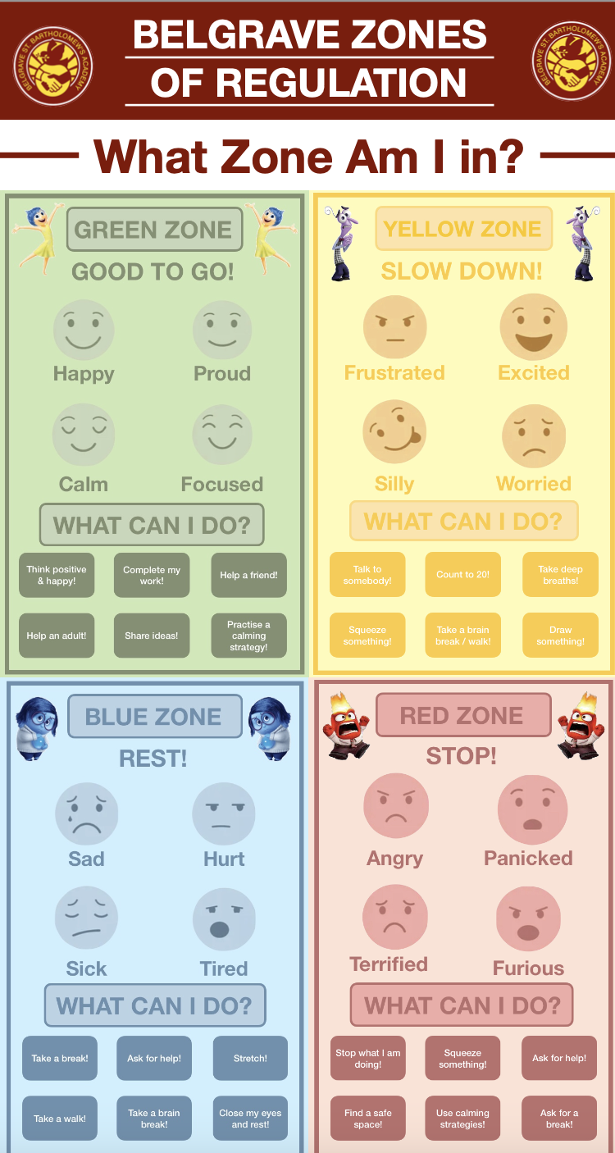

APPENDIX 2: Value Driven Behaviours

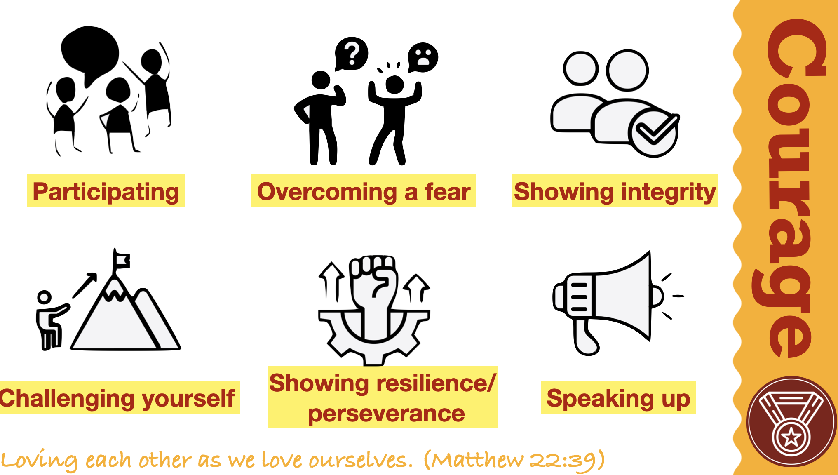

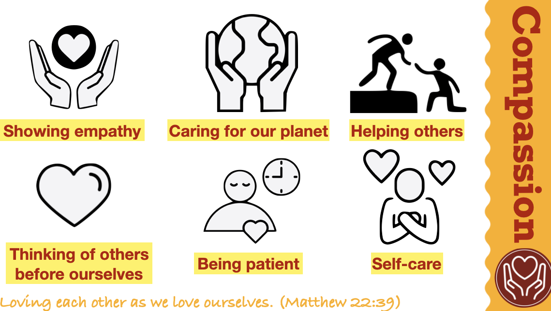
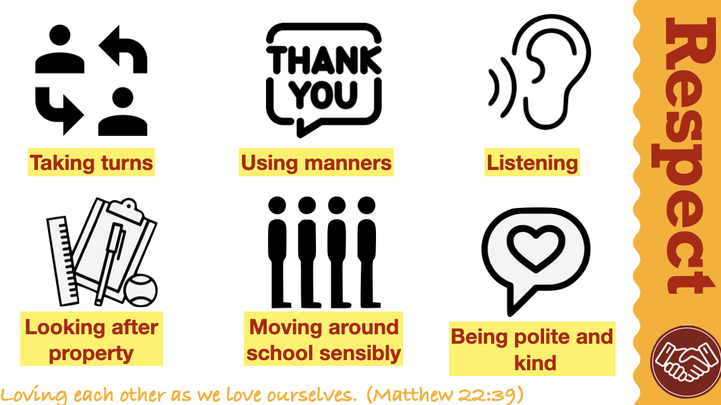

APPENDIX 3: ABC Chart

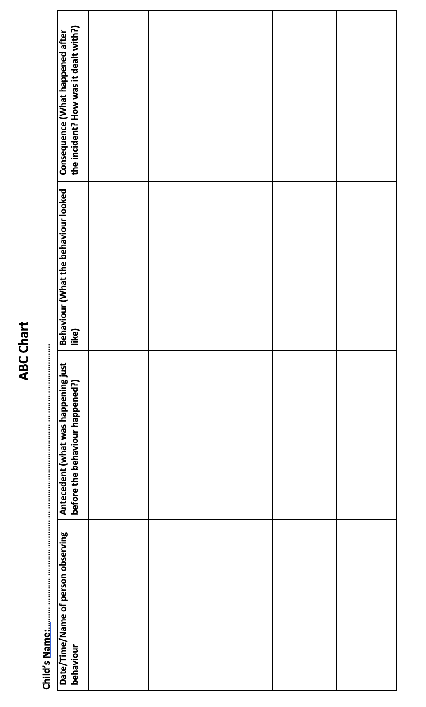

APPENDIX 4: Structured Behaviour Approach

