Belgrave St. Bartholomew’s

Academy

Co-principals:

Mrs Rachel McNamara, Mrs Luci Baker

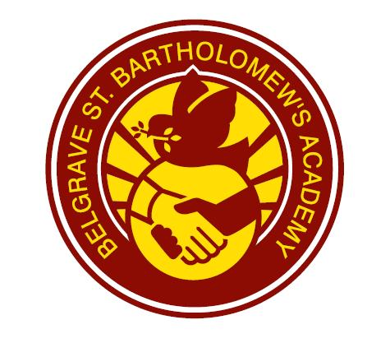
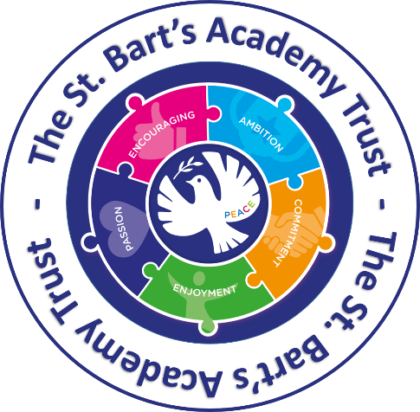

‘School Travel Policy’ -

2026-7

If you would like this translated in Urdu, please contact the school office.

SCHOOL TRAVEL POLICY

We actively encourage our pupils and staff to walk, scoot or cycle to school as it helps:

keep us fit and healthy

our pupils develop road safety skills which will keep them safe as they travel further afield and more independently

keep our local air clean, and our streets free from congestion

develop life skills that everyone should be able to benefit from

What we do

We promote safe and active travel as much as possible by, where appropriate, using our displays, newsletters, social media sites and website at www.belgraveacademy.org.uk

We encourage all members of our school community to walk, cycle or travel by public transport for the journey to school. To support this we provide:

o Cycle training (Bikeability)
o Cycle parking
o Scooter parking
o Safe spaces for helmets/equipment

o Public transport information

Badge incentives through the Travel Tracker scheme

Local school trips are made by school minibus, or on foot if the destination is close by

We let all new pupils and their parents/carers know that we promote healthy and sustainable travel to school before the child starts at our school

What we ask of parents/carers

Please encourage your child(ren) to walk, scoot or cycle to school whenever possible

Ensure your child(ren) walk or ride sensibly and safely on the way to and from school and to push bikes and scooters on school grounds

Ensure that bicycles and scooters are roadworthy and properly maintained. If in doubt consult a qualified mechanic

Provide your child(ren) with a cycle helmet
Ensure your child(ren) can be seen by fitting lights to their bike and supplying them with high-visibility clothing

