

Religious Education Policy
An inclusive family under God
‘Loving each other as we love ourselves.’
Matthew 22:39

Date Approved: September 2026

Review date: September2027


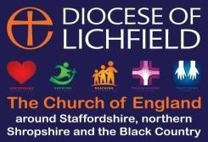

Rationale for RE at Belgrave St Bartholomew’s Academy

Belgrave St Bartholomew’s Academy is an inclusive school under God, that values everyone as a child of God and rejoices in its diversity. Our vision is to provide a happy, loving and nurturing environment where all have the confidence to make outstanding progress and so expand and fulfil their hopes and aspirations. Our inspiring, enriched curriculum promotes a thirst for knowledge and develops wisdom.

The subject of Religious Education (RE) is regarded as a core subject within the school’s curriculum. It has a vital role in developing religious literacy and deepening pupils understanding of Christianity, in all its forms, and fostering appreciation and understanding of other faith traditions. RE is non-confessional and should be treated as an academic subject in its own right.

As the Church of England document, ‘Making a difference? A review of Religious Education in Church of England schools 2014’ recommends that the RE curriculum in all schools should,

“……. ensure it provides a more coherent, progressive and challenging approach to the teaching of Christianity within the context of the wider exploration of the diversity of religion and belief in the modern world”
“……explore ways of extending pupils’ ability to think theologically and engage in theological enquiry as part of their learning in RE”

RE Statement of Entitlement
RE teaching at this school will be in line with the recommendations of the Statement of Entitlement for Church Schools, published by the Church of England Education Office (February 2019), see link below and Appendix A:

https://www.churchofengland.org/sites/default/files/2019-02/re-statement-of-entitlement-for-church-schools.pdf

Christianity will, therefore, be no less than half (50%) of RE curriculum time. The teaching of Christianity is core to the teaching of RE in this Church of England school. However, as a Church school we have a duty to foster an accurate and increasing understanding of world religions and worldviews. As a result, pupils will gain greater insight into the world in which they are growing up. They will also learn to appreciate the faith of others, including non-faith views, developing a deeper understanding of their own ideas and beliefs. These outcomes must contribute to harmonious relationships within and between communities, promoting social inclusion and combating prejudice and discrimination.

The RE curriculum
RE teaching follows the legal requirements of the Education Reform Act (1988), which places RE as part of the basic curriculum; a statutory subject which is an entitlement for all pupils. The school bases it on the decision made by the governing body. In addition, the school uses the Lichfield Diocesan RE Guidelines, Understanding Christianity resources and the Stoke on Trent RE syllabus to enhance teaching and learning.
The principal aim of religious education is to explore what people believe and what difference this makes to how they live, so that pupils can gain the knowledge, understanding and skills needed to handle questions raised by religion and belief, reflecting on their own ideas and ways of living.

• Religious education contributes dynamically to children and young people’s education by provoking challenging questions about meaning and purpose in life, beliefs about God, ultimate reality, issues of right and wrong and what it means to be human.
• In RE pupils learn about religions and beliefs in local, national and global contexts, to discover, explore and consider different answers to these questions.
• Pupils learn to weigh up the value of wisdom from different sources, to develop and express their insights in response and to agree or disagree respectfully.
• Teaching equips pupils with systematic knowledge and understanding of a range of religions and beliefs, enabling them to develop their ideas, values and identities.
• RE should develop pupils aptitude for dialogue so that they can participate positively in our society, with its diverse religions and beliefs.
• Pupils gain and deploy the skills needed to understand, interpret and evaluate texts, sources of wisdom and authority and other evidence. They learn to articulate clearly and coherently their personal beliefs, ideas, values and experiences while respecting the right of others to differ.

The purpose of RE is captured in the principal aim, which is intended to be a shorthand version for day-to-day use. It should be considered as a doorway into the wider purpose articulated above.

The threefold aim of RE elaborates the principal aim. The curriculum for RE aims to ensure that all pupils:

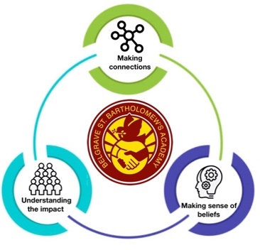
1. make sense of a range of religious and non-religious beliefs, so that they can:
• identify, describe, explain and analyse beliefs and concepts in the context of living religions, using appropriate vocabulary
• explain how and why these beliefs are understood in different ways, by individuals and within communities
• recognise how and why sources of authority (e.g. texts, teachings, traditions, leaders) are used, expressed and interpreted in different ways, developing skills of interpretation

2. understand the impact and significance of religious and non-religious beliefs, so that they can:
• examine and explain how and why people express their beliefs in diverse ways
• recognise and account for ways in which people put their beliefs into action in diverse ways, in their everyday lives, within their communities and in the wider world
• appreciate and appraise the significance of different ways of life and ways of expressing meaning

3. make connections between religious and non-religious beliefs, concepts, practices and ideas studied, so that they can:
• evaluate, reflect on and enquire into key concepts and questions studied, responding thoughtfully and creatively, giving good reasons for their responses
• challenge the ideas studied, and allow the ideas studied to challenge their own thinking, articulating beliefs, values and commitments clearly in response
• discern possible connections between the ideas studied and their own ways of understanding the world, expressing their critical responses and personal reflections with increasing clarity and understanding

RE Curriculum overview:

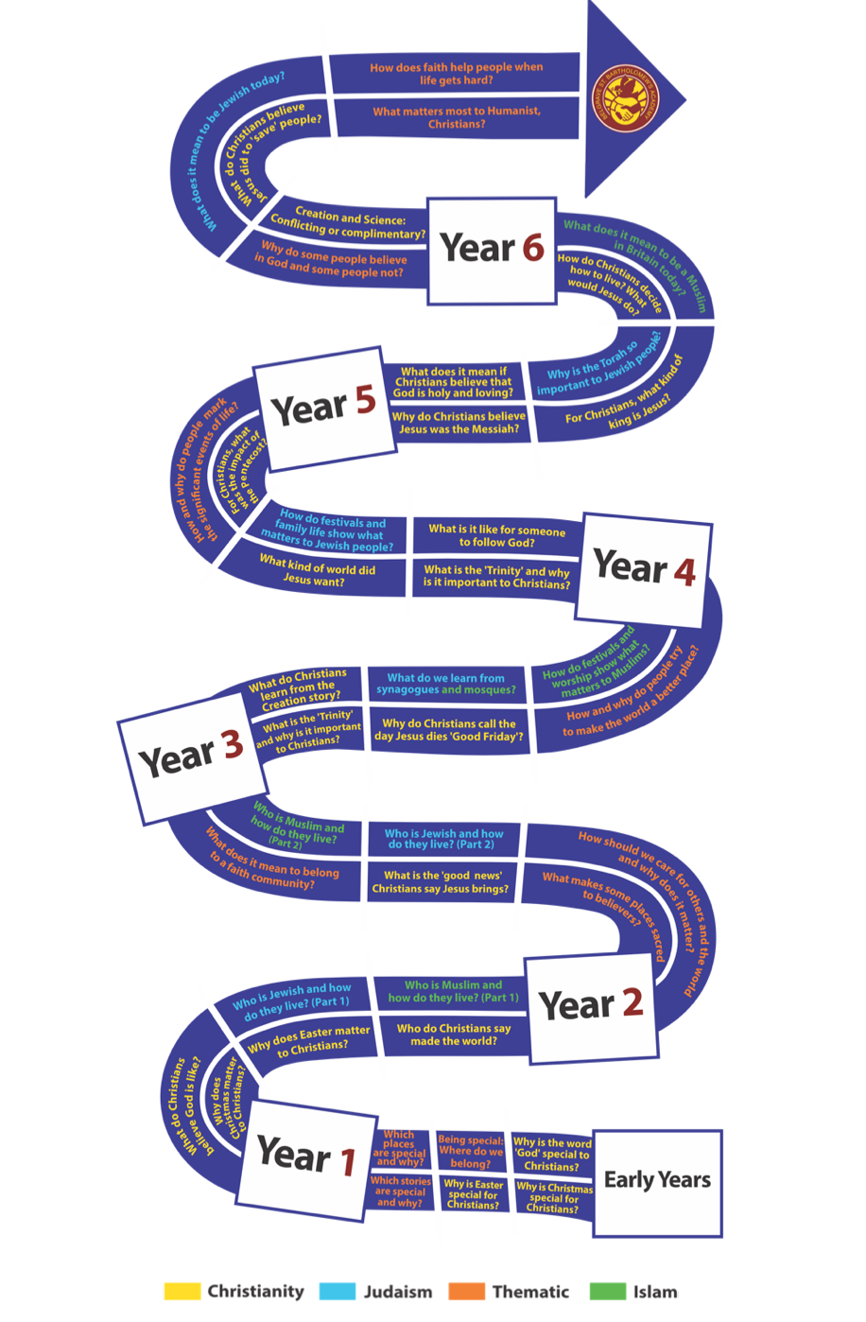

Spiritual, moral, social and cultural development (SMSC)
In addition, the subject contributes to other areas of education and experience and plays an important part of the wider programme of spiritual, moral, social and cultural (SMSC) development.

Spiritual | Widening pupils’ vision of themselves and their own experience, within the context of a growing awareness and understanding of God.
Moral | Helping each pupil develop their own informed values
Social | Helping pupils understand some major forces shaping the values of our society
Cultural | Aiding pupils in exploring aspects of their own cultural heritage and developing positive attitudes towards diversity.

Additional links will be found across the curriculum especially with personal, social, health and citizenship education (PSHE) and British values. RE can also make a positive contribution to enhancing creativity and enjoyment and ensure the well-being of all pupils.

The management of RE
RE is given equal status with other core subjects in staffing, responsibility and resourcing. Pupil achievement in RE should equal or be better than comparable subjects. Teachers should share effective practice locally and regionally and engage in professional development (SIAMS September 2022).

As a church school we recognise that it should be a priority to build up staff expertise in RE.

The RE subject leader is responsible for:
- producing a scheme of work document for the school, including long term and medium term plans.
- supporting colleagues in the detailed planning and delivery of RE provision
- ensuring Religious Education has high status within the school
- keeping in touch with subject developments and disseminating information as appropriate
- auditing and recording current resources, supplementing resource provision when money is available and disseminating this information to staff
- undertaking personal development and subject training
- monitoring RE provision, practice and outcomes
- ensuring there are rigorous and effective systems that enable teachers to know how and what pupils are learning in RE (SIAMS September 2022)
- accountability for RE standards in the school
- meeting with members of the Diocesan RE advisory team when possible

Right to withdrawal - see appendix 1
At Belgrave St Bartholomew’s Academy we wish to be an inclusive community but recognise that parents have the legal right to withdraw their children from religious education or collective worship on the grounds of conscience, without giving a reason. Parents wishing to exercise this right are asked to write to the headteacher who will then invite the parents into school to discuss their concerns, clarify the nature of the RE and worship provided by the school and set out the options open to the parents as set out in education law. However, the right of withdrawal does not extend to other areas of the curriculum when, as may happen on occasion, spontaneous questions on religious matters are raised by pupils or there are issues related to religion that arise in other subjects. Where a pupil is withdrawn from RE and do not take part in alternative religious education they will be supervised by an appropriate member of staff whilst doing work set by their parents which will seek to further their knowledge and understanding of their parents’ beliefs and values.

Review
The policy will be reviewed annually.

Appendix 1
Guidance for schools and academies on the right to withdrawal from Religious Education March 2017

Religious Education
The government guidance Religious Education in English schools: Non-statutory guidance 2010 states that:

Every maintained school in England must provide a basic curriculum (RE, sex education and the National
Curriculum). This includes provision for RE for all registered pupils at the school (including those in the sixth form), except for those withdraws by their parents (or withdrawing themselves if they are aged 18 or over)

In voluntary controlled schools and academies, religious education must be provided in accordance with the local Agreed Syllabus provided by the SACRE (Standing Advisory Council for Religious Education) of the local authority in which the school is situated.

In voluntary aided schools and academies, the decision on the content of religious education rests with the Governing Body, and should be in line with the Trust Deeds of the school.

In all forms of church school, the religious education provided should contribute to the Christian character of the school, and this is in aspect of the school’s work which is subject to the Statutory Inspection of Anglican and Methodist Schools (SIAMS), whether VC, VA or academy.

Parents have the legal right to withdraw their children form religious education on the grounds of conscience. However, the right of withdrawal does not extend to other areas of the curriculum when, as may happen on occasion, spontaneous questions on religious matters are raised by pupils or there are issues related to religion that arise in other subjects such as history or citizenship. (Non-statutory Guidance 2010)

Any parent considering withdrawal must contact the Headteacher / Principal to discuss any concerns relating to the policy, provision and practice of religious education at the school.

Managing the Right of Withdrawal
It is important that the school makes clear on its website and through other forms of communication, the RE syllabus being taught in school. There needs to be a clear understanding of the relevance of the RE curriculum and how it respects pupils own beliefs. It is good practice to review requests to withdraw from RE and collective worship annually.

Consideration needs to be given to:
- Whether the parents wish their children to be withdrawn from the whole of the subject or specific parts of it.
- Parents can withdraw their child from a specific activity, such as a visit to a place of worship, and not withdraw their child from the remainder of the RE.
- Where pupils are withdrawn from RE or collective worship, schools have a duty to supervise them, though not to provide additional teaching or incur extra cost.
- Where a pupil has been withdrawn from RE, the law provides for alternative arrangements to be made for RE of the kind the parent wants the pupil to receive. This could be provided at the school or the pupil could be sent to another school where suitable RE is provided. Outside arrangements are permitted providing the necessary safeguarding procedures are in place and the LA or Trust Board is satisfied that any interference with the pupil’s attendance at school resulting from withdrawal will only affect the start or end of a school session (Non-statutory Guidance 2010)
It is important that schools are fully aware of issues surrounding religion, race and culture and ensure that parental right to withdrawal requests to not hamper their responsibilities to ensure equality for all and the promotion of British Values.

